**Part 10 – Solving Absolute Value Equations**

**Absolute Value Definition:** The distance between the number and 0 on a number line.

**Example.** Solve the equation

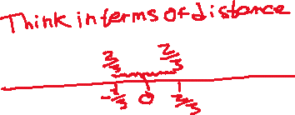

**Example.** Solve the equation



**Example.** Solve the equation

